TRANSMISSION LINES & WAVEGUIDES – ECA1501
NAME: R.Varsha
REG: 192412659
DATE: 12-10-2026
EXPERIMENT – 1
Estimation of Characteristic Impedance (Z₀) and Propagation Constant (γ) of a Transmission Line

AIM
To investigate the significance of the characteristic impedance (Z₀) and propagation constant (γ) of a transmission line using its primary constants R, L, G and C, and to study the effect of resistance, inductance, frequency and capacitance.
SOFTWARE REQUIRED
SCILAB Version 6.1.1

THEORY / FORMULAE
Characteristic impedance:
Z₀ = √[(R + jωL)/(G + jωC)]
Propagation constant:
γ = √[(R + jωL)(G + jωC)] = α + jβ
where α is the attenuation constant in neper/km, β is the phase constant in radians/km, and ω = 2πf.

PROCEDURE
- Open SCILAB software.
- Open a new file.
- Enter the required values of R, L, G, C and frequency.
- Type and execute the SCILAB program.
- Record Z₀, α and β.
- Repeat the calculation for each variation specified in the test cases.

TEST CASE 1 – BASIC CALCULATION
Investigate Z₀ and γ for the given transmission-line primary constants.

Parameter | Value | Unit
R | 10 | Ω/km
L | 3.5 | mH/km
C | 8 | µF/km
G | 4 | µmho/km
f | 2 | kHz

TEST CASE 1 – RESULT TABLE
S.No. | Input | Z₀ (Ω) | α (neper/km) | β (rad/km) | Status
1 | R=10, L=3 mH, C=16 µF, G=4 µmho, f=2 kHz | 14 − j2 | 0.3621 | 2.7769 | Matches attached SCILAB output

TEST CASE 2 – EFFECT OF RESISTANCE AND INDUCTANCE
At f = 2.5 kHz, the resistance is varied from 10 Ω to 50 Ω in steps of 10 Ω while the other constants are kept fixed. The inductance is varied from 3.5 mH to 11.5 mH with R, G and C constant, as specified in the lab manual.
- Variable Resistance (R): L = 3.5 mH/km, C = 8 µF/km, G = 4 µmho/km, f = 2.5 kHz
S.No. | R (Ω/km) | Z₀ (Ω) –  Simulation* | α – Simulation* | β – Simulation* | α – Theory | β – Theory
1 | 10 | 21.00 − j1.89 | 0.2381 | 2.6392 | 0.2381 | 2.6392
2 | 20 | 21.25 − j3.74 | 0.4707 | 2.6702 | 0.4707 | 2.6702
3 | 30 | 21.63 − j5.52 | 0.6935 | 2.7184 | 0.6935 | 2.7184
4 | 40 | 22.12 − j7.19 | 0.9042 | 2.7796 | 0.9042 | 2.7796
5 | 50 | 22.68 − j8.77 | 1.1023 | 2.8502 | 1.1023 | 2.8502

- Variable Inductance (L): R = 10 Ω/km, C = 8 µF/km, G = 4 µmho/km, f = 2.5 kHz

S.No. | L (mH/km) | Z₀ (Ω) –  Simulation* | α – Simulation* | β – Simulation* | α – Theory | β – Theory
1 | 3.5 | 21.00 − j1.89 | 0.2381 | 2.6392 | 0.2381 | 2.6392
2 | 6.0 | 27.42 − j1.45 | 0.1824 | 3.4463 | 0.1824 | 3.4463
3 | 8.5 | 32.62 − j1.22 | 0.1534 | 4.0990 | 0.1534 | 4.0990
4 | 11.0 | 37.10 − j1.07 | 0.1349 | 4.6617 | 0.1349 | 4.6617

TEST CASE 3 – EFFECT OF FREQUENCY AND CAPACITANCE
The frequency is varied from 2 kHz to 10 kHz in steps of 2 kHz with L, R, G and C constant. Capacitance is varied from 8 µF to 16 µF in steps of 2 µF with R, L and G constant, as specified in the lab manual.
- Variable Frequency (f): R = 10 Ω/km, L = 3.5 mH/km, C = 8 µF/km, G = 4 µmho/km

S.No. | f (kHz) | Z₀ (Ω) –  Simulation* | α – Simulation* | β – Simulation* | α – Theory | β – Theory
1 | 2 | 21.05 − j2.36 | 0.2376 | 2.1161 | 0.2376 | 2.1161
2 | 4 | 20.95 − j1.19 | 0.2387 | 4.2123 | 0.2387 | 4.2123
3 | 6 | 20.93 − j0.79 | 0.2389 | 6.3128 | 0.2389 | 6.3128
4 | 8 | 20.92 − j0.59 | 0.2390 | 8.4144 | 0.2390 | 8.4144
5 | 10 | 20.92 − j0.48 | 0.2390 | 10.5165 | 0.2390 | 10.5165

- Variable Capacitance (C): R = 10 Ω/km, L = 3.5 mH/km, G = 4 µmho/km, f = 2 kHz
S.No. | C (µF/km) | Z₀ (Ω) –  Simulation* | α – Simulation* | β – Simulation* | α – Theory | β – Theory
1 | 8 | 21.05 − j2.36 | 0.2376 | 2.1161 | 0.2376 | 2.1161
2 | 10 | 18.83 − j2.11 | 0.2656 | 2.3659 | 0.2656 | 2.3659
3 | 12 | 17.19 − j1.93 | 0.2910 | 2.5917 | 0.2910 | 2.5917
4 | 14 | 15.91 − j1.79 | 0.3143 | 2.7994 | 0.3143 | 2.7994
5 | 16 | 14.88 − j1.67 | 0.3360 | 2.9927 | 0.3360 | 2.9927

SCILAB PROGRAM

clear;
clc;

// Given parameters
R = 10; // Resistance in ohms/m
L = 0.003; // Inductance in H/m
f = 2 * 10^3; // Frequency in Hz
G = 4 * 10^(-6); // Conductance in S/m
Cap = 16 * 10^(-6); // Capacitance in F/m

// Angular frequency
w = 2 * %pi * f;

// Series impedance
Z = R + %i * w * L;

// Shunt admittance
Y = G + %i * w * Cap;

// Characteristic impedance
Zo = sqrt(Z / Y);

Zo_R = real(Zo);
Zo_X = imag(Zo);

printf("Characteristic impedance:\n");
printf("Zo = %.4f + j(%.4f) ohms\n", Zo_R, Zo_X);

// Propagation constant
P = sqrt(Z * Y);

// Attenuation constant
alpha = real(P);

printf("\nAttenuation constant:\n");
printf("alpha = %.6f neper/m\n", alpha);
printf("alpha = %.4f neper/km\n", alpha * 1000);

// Phase constant
beta = imag(P);

printf("\nPhase constant:\n");
printf("beta = %.6f radians/m\n", beta);
printf("beta = %.4f radians/km\n", beta * 1000);
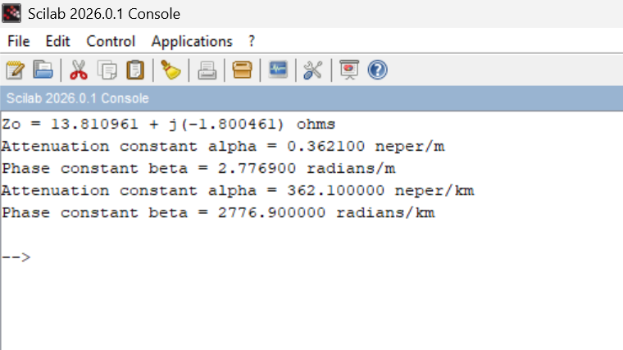

RESULTS
Test Case 1: The attached SCILAB output gives Z₀ = 14 − j2 Ω, α = 0.3621 neper/km and β = 2.7769 radians/km.
Test Case 2: The effect of resistance and inductance on Z₀, α and β was evaluated for the ranges specified in the manual.
Test Case 3: The effect of frequency and capacitance on Z₀, α and β was evaluated for the ranges specified in the manual.

